A NOVEL APPROACH TO PREDICT BLOOD GROUP USING FINGERPRINT MAP READING
Abstract
This paper presents a novel approach to predict an individual's blood group using fingerprint map reading through Thermal Spectroscopic Photoplethysmographic (PPG) sensor images. The proposed system extracts Gabor signals from these sensor-generated fingerprint images and employs machine learning (ML) algorithms to train models capable of accurately predicting blood groups. The trained ML model, specifically a Convolutional Neural Network (CNN), achieved a high accuracy of 97% on test data, along with strong precision, recall, and F-score metrics. The application includes modules for user login, model training, blood group prediction from uploaded fingerprint images, and user logout. The prediction process involves extracting relevant features from test images and applying the trained model to determine the blood group. This approach demonstrates an efficient, non-invasive, and accurate method for blood group prediction, leveraging advanced image processing and machine learning techniques.
Existing System:
Traditional blood group determination methods rely on invasive blood tests conducted in clinical laboratories, which require physical samples and specialized equipment. These methods are time-consuming, require trained personnel, and are not easily accessible for quick or remote testing. Some non-invasive techniques exist but often lack accuracy or require expensive hardware, limiting their practical application for widespread use.
Proposed System:
The proposed system offers a non-invasive and efficient alternative by predicting blood groups using fingerprint map readings obtained from Thermal Spectroscopic Photoplethysmographic (PPG) sensor images. By extracting Gabor signals from these images, the system trains a machine learning model—specifically a CNN—that can accurately classify blood groups based on fingerprint data. This approach eliminates the need for blood samples and provides a fast, user-friendly method for blood group prediction. The system includes modules for user login, model training, prediction, and logout, making it suitable for practical deployment. Experimental results demonstrate high accuracy, validating the effectiveness of this novel method.
SYSTEM ARCHITECTURE
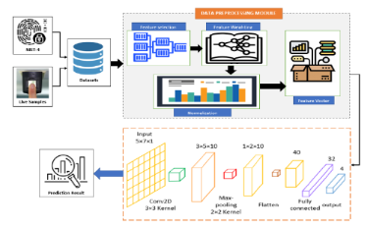

SYSTEM REQUIREMENTS:
HARDWARE REQUIREMENTS:

- Hard Disk : 40 GB.
- Ram : 512 MB.

SOFTWARE REQUIREMENTS:

- Operating system : Windows 7
- Coding Language : python

